### A Hidden Message Card

A hidden message card is a fun way to send a greeting. You pull on a tab and the shutters move to reveal a message. This design is very versatile and it can be used to make a pop-up book.

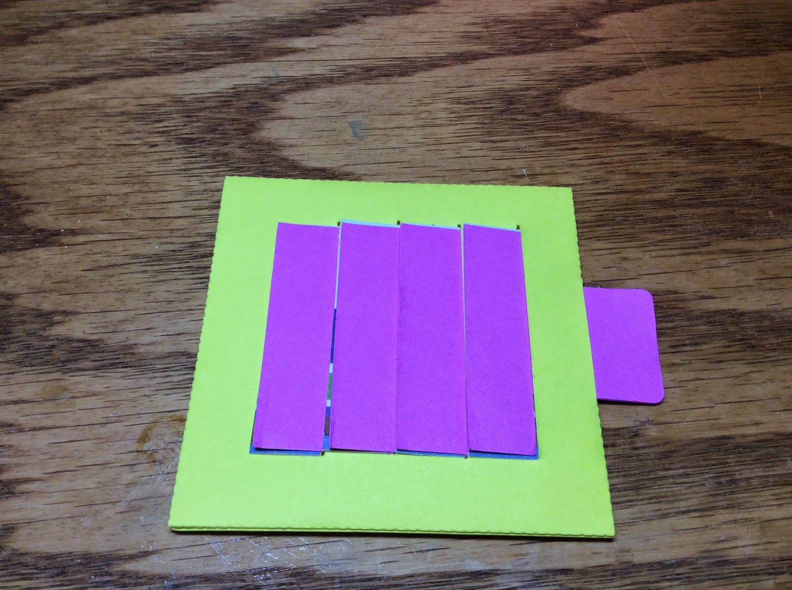

Shutters are closed.

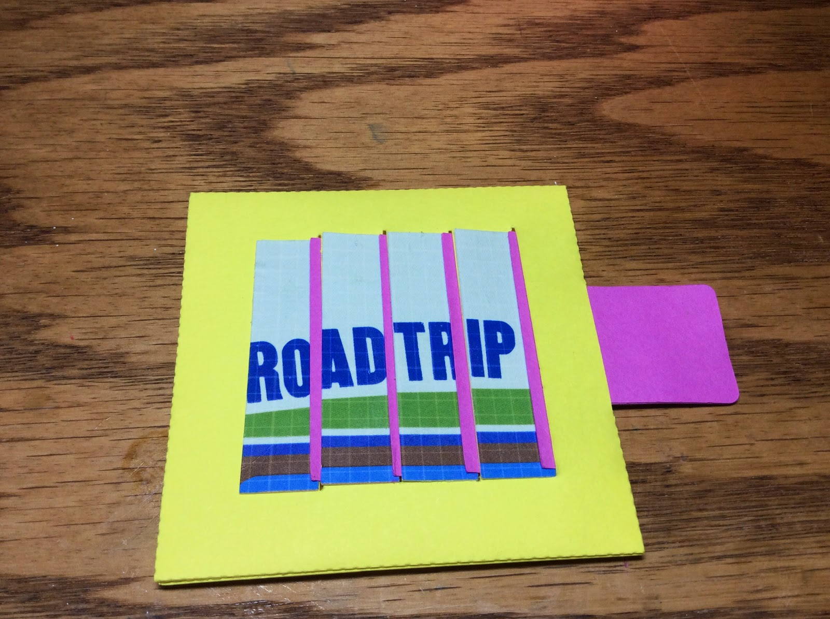

Shutters are open to reveal a message.

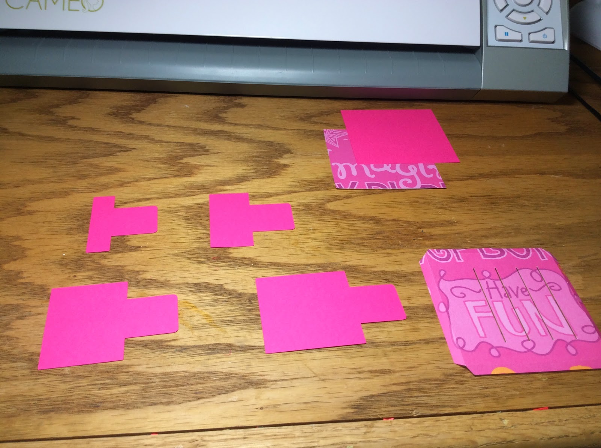

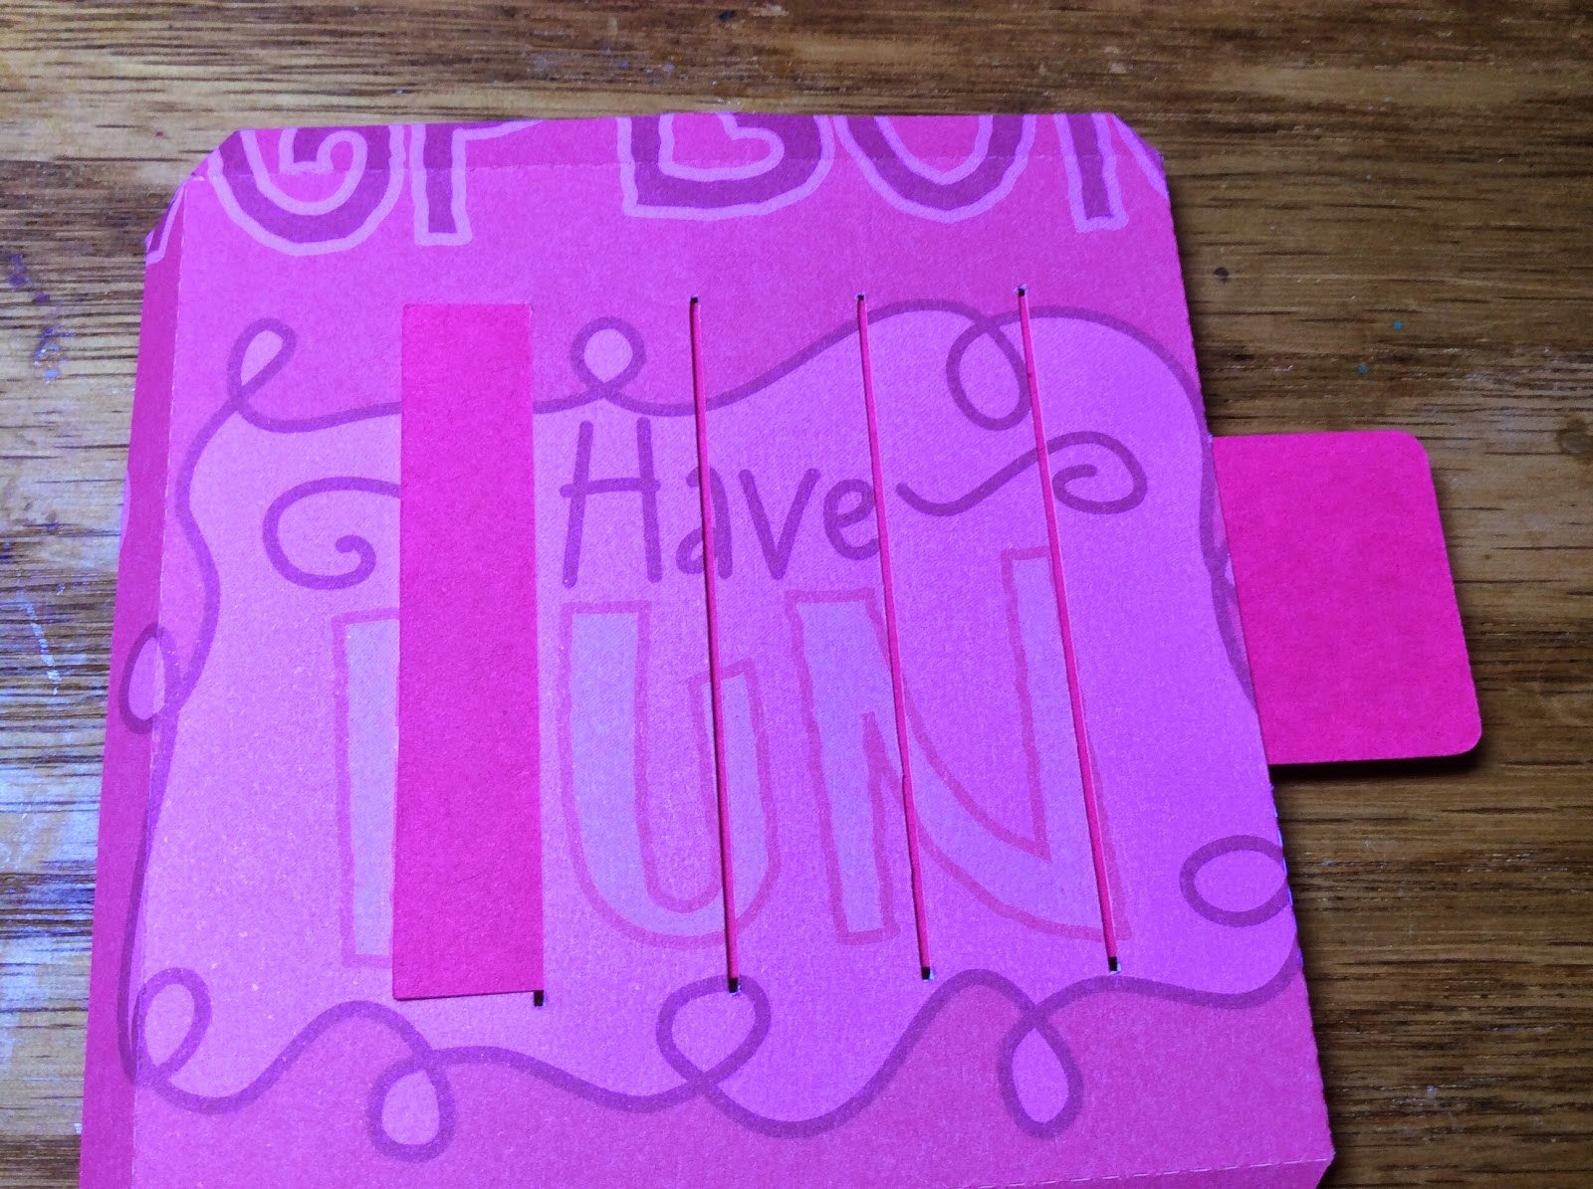

Thread the largest tab through the back as shown above.

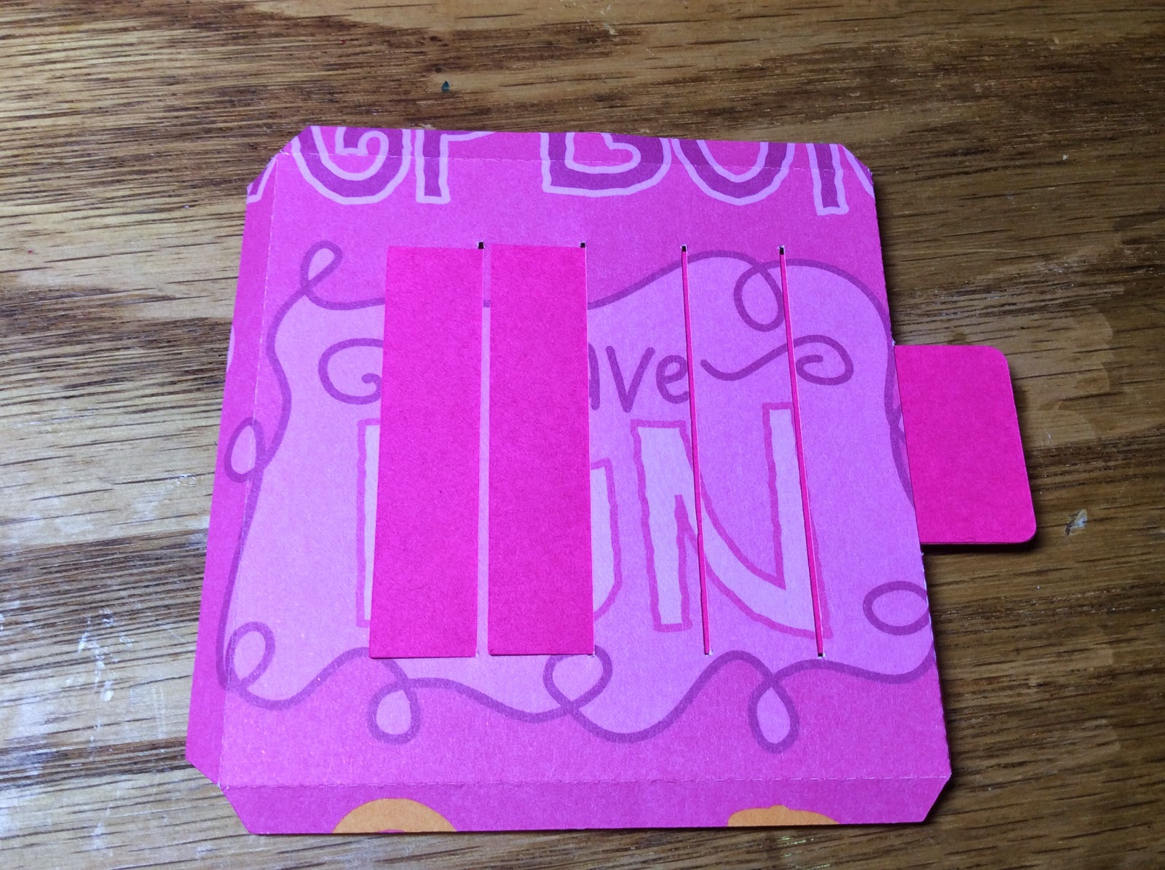

Thread the next size tab.

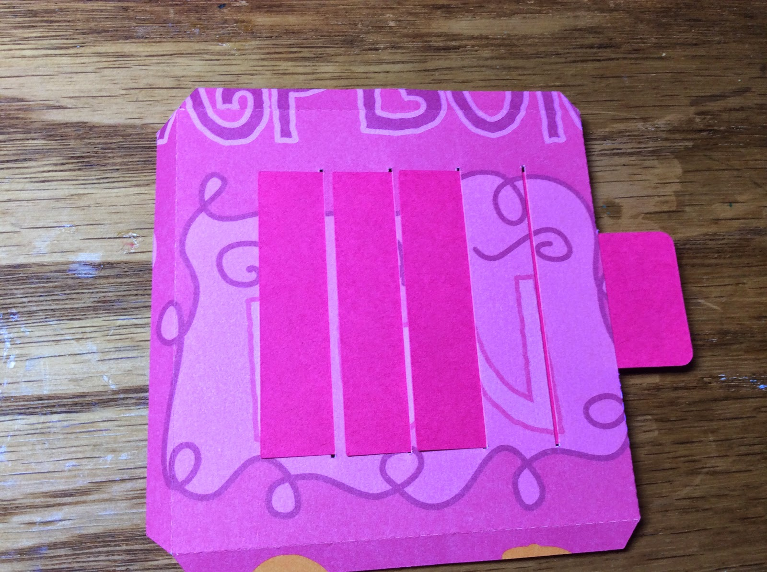

Thread the next smaller tab.

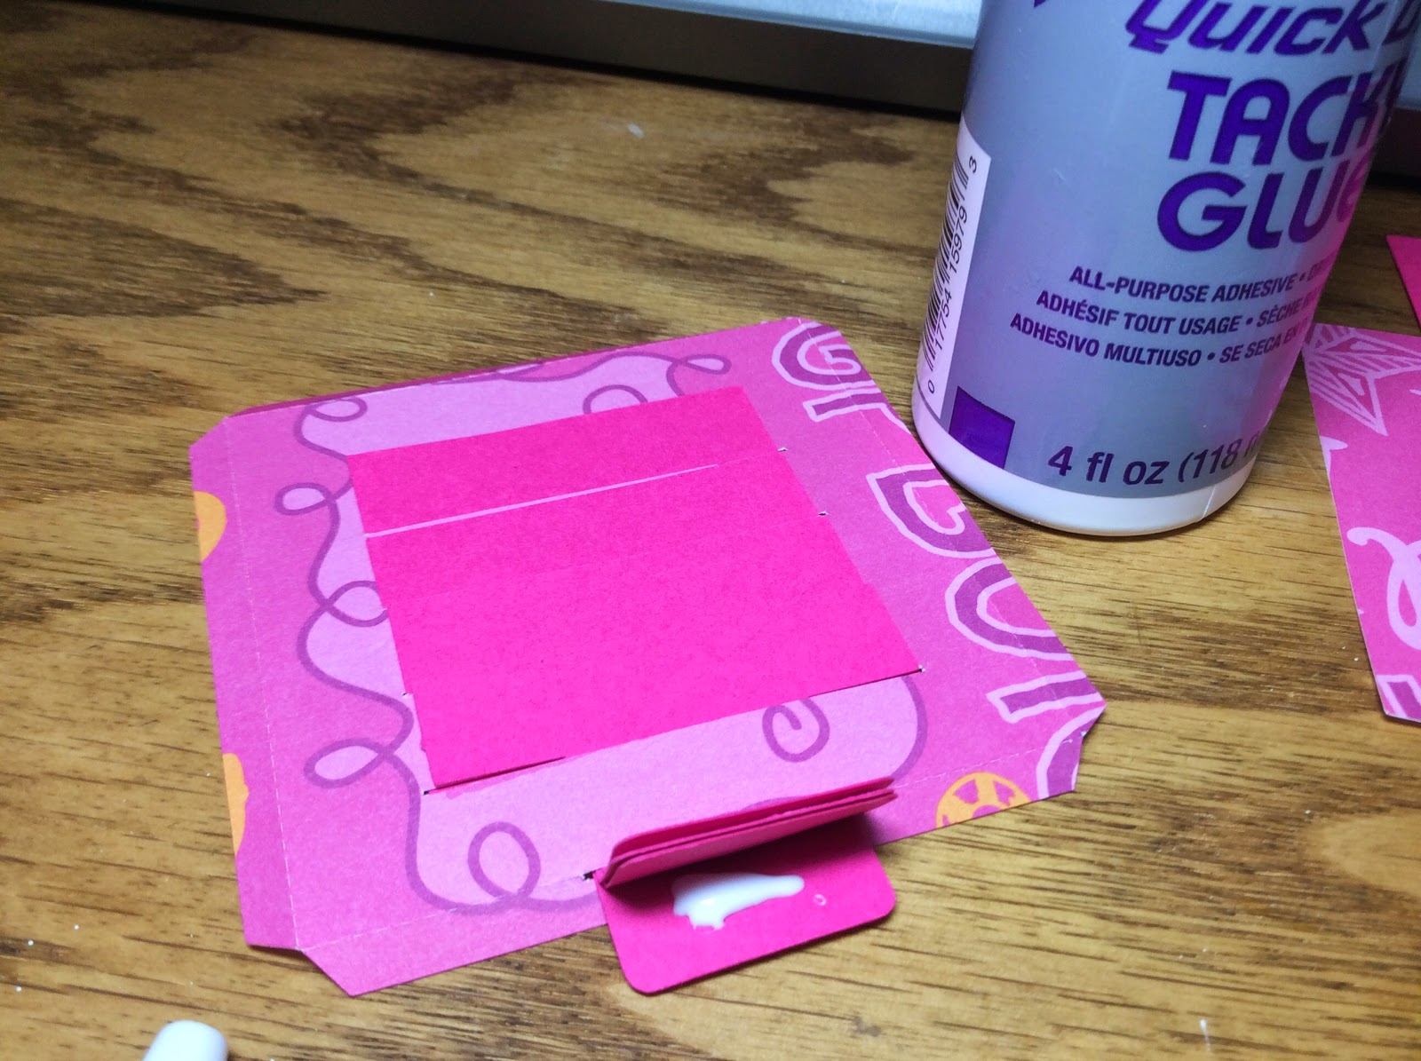

Glue the tabs together as shown

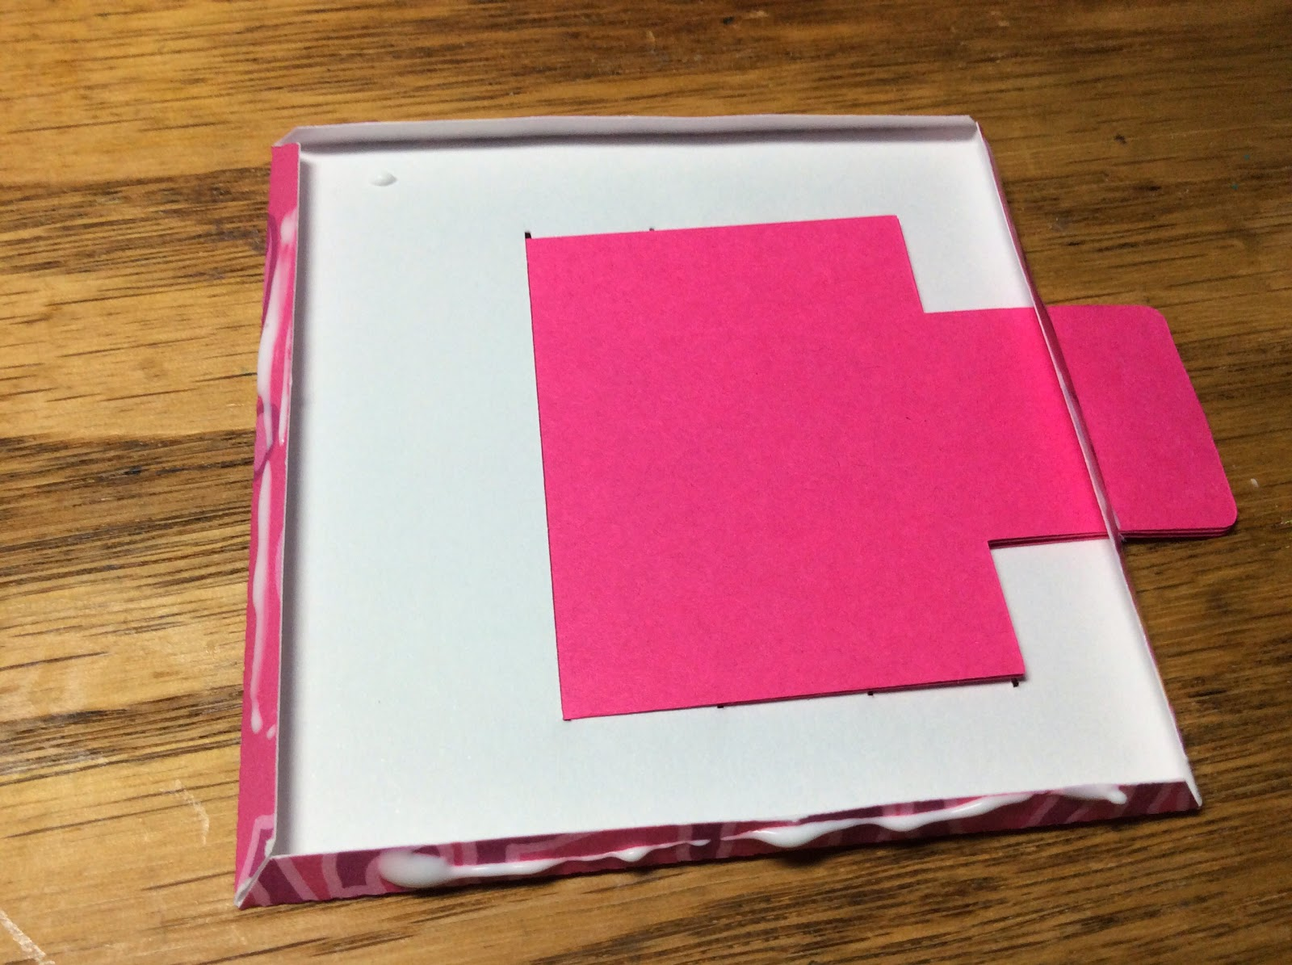

Fold over the edges and apply glue.

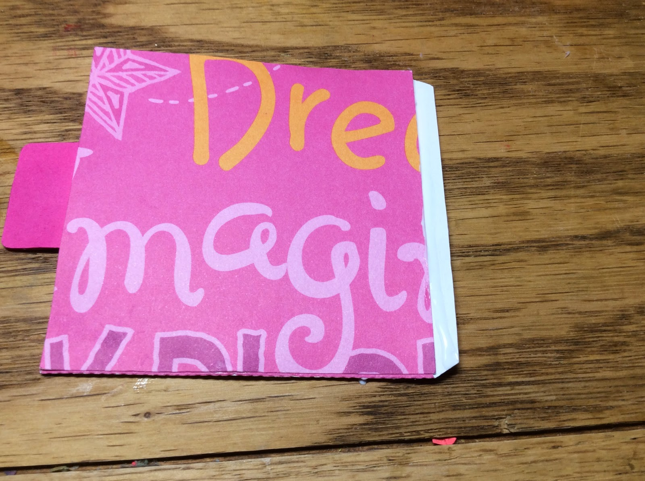

Leave one tab out.

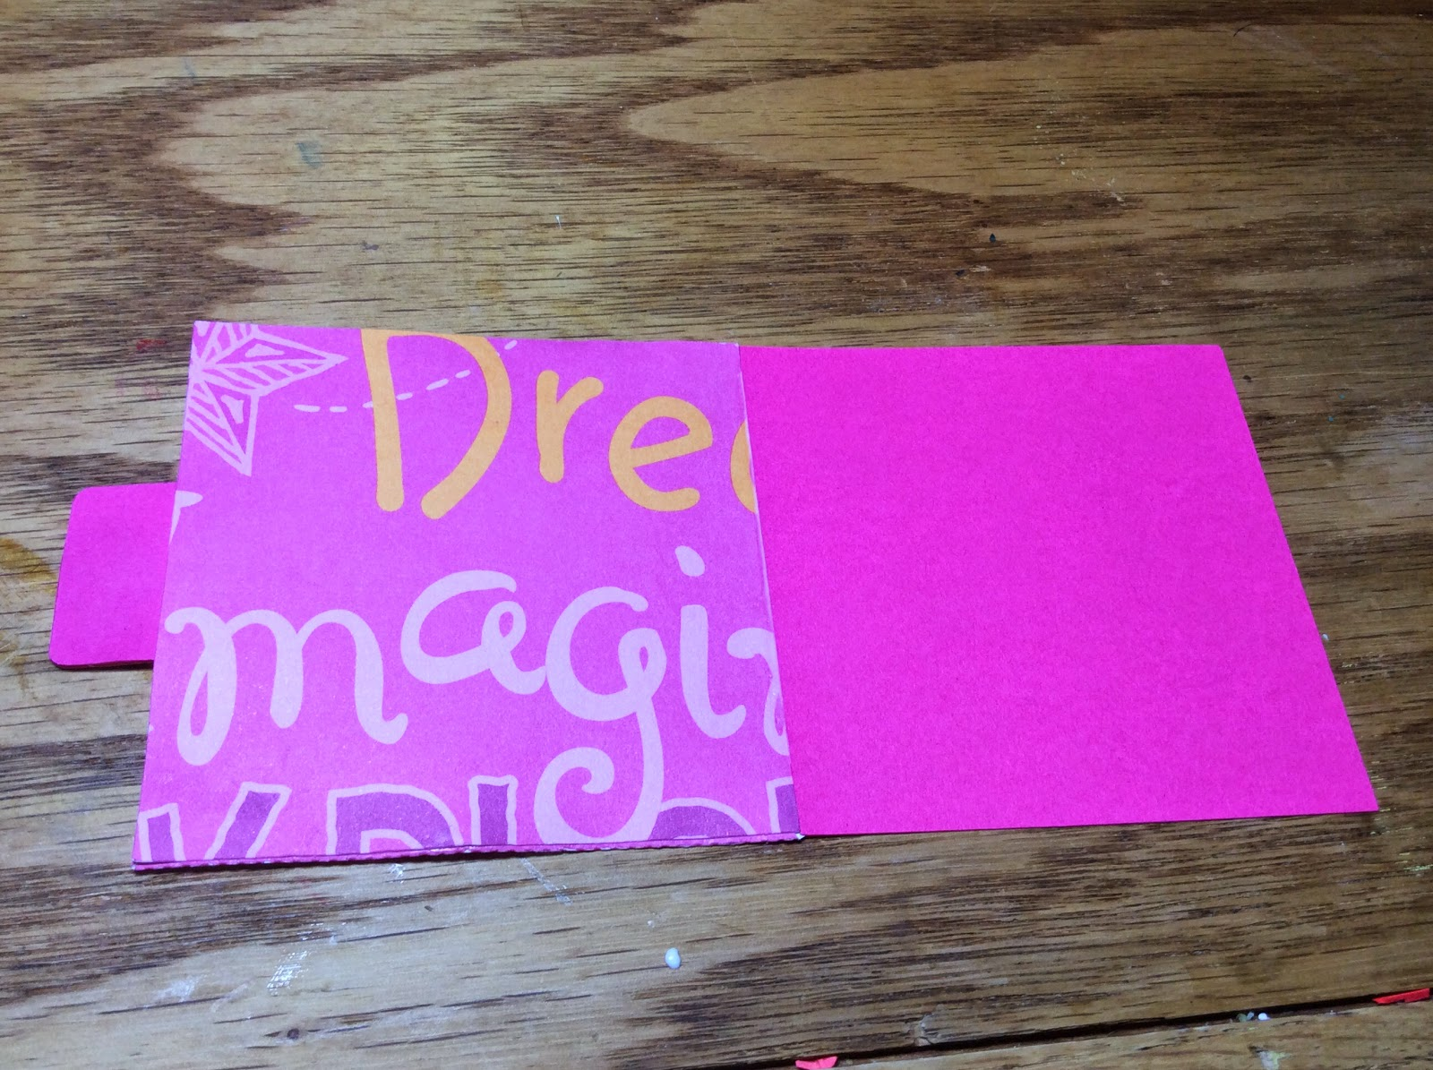

Attach the other side of the card.

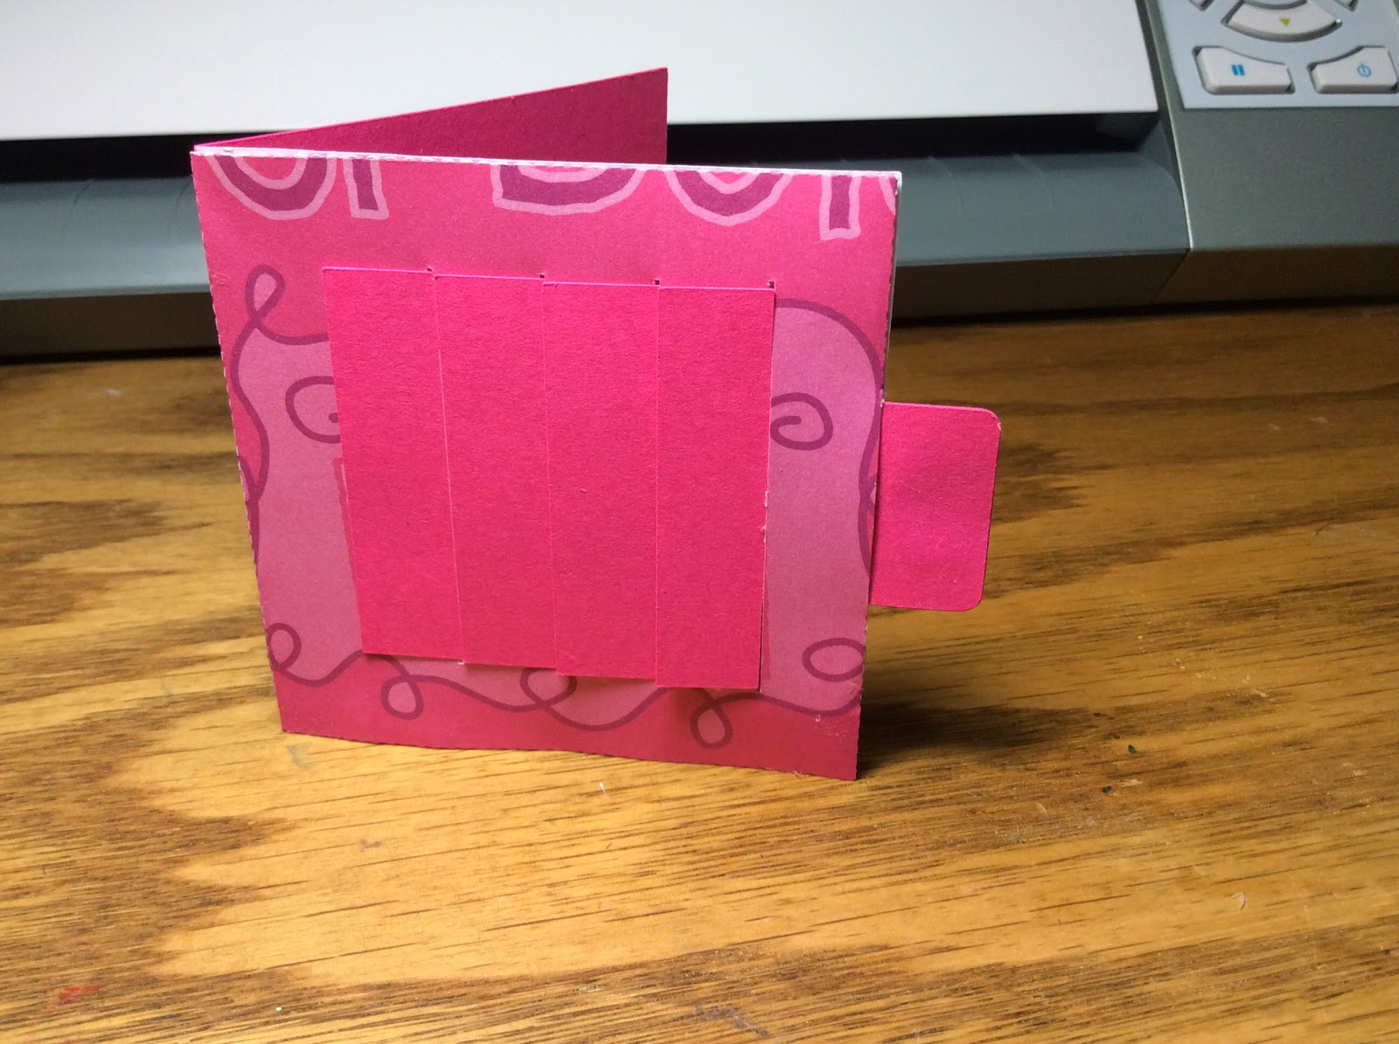

Completed shutter card.

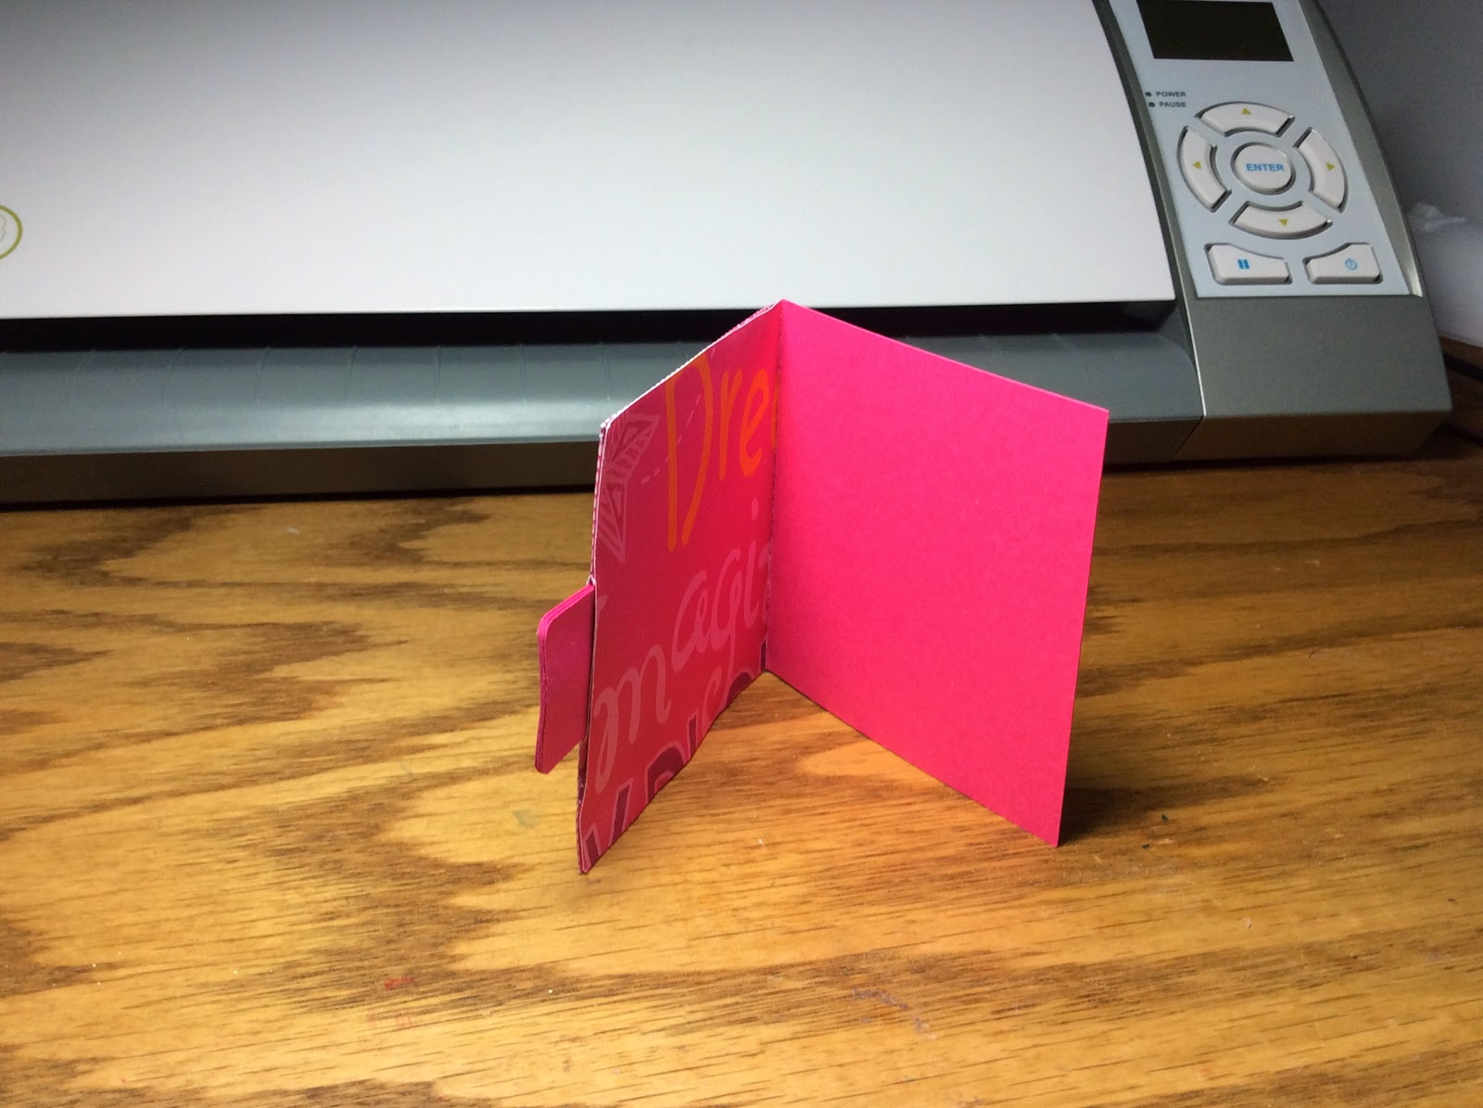

Inside view.

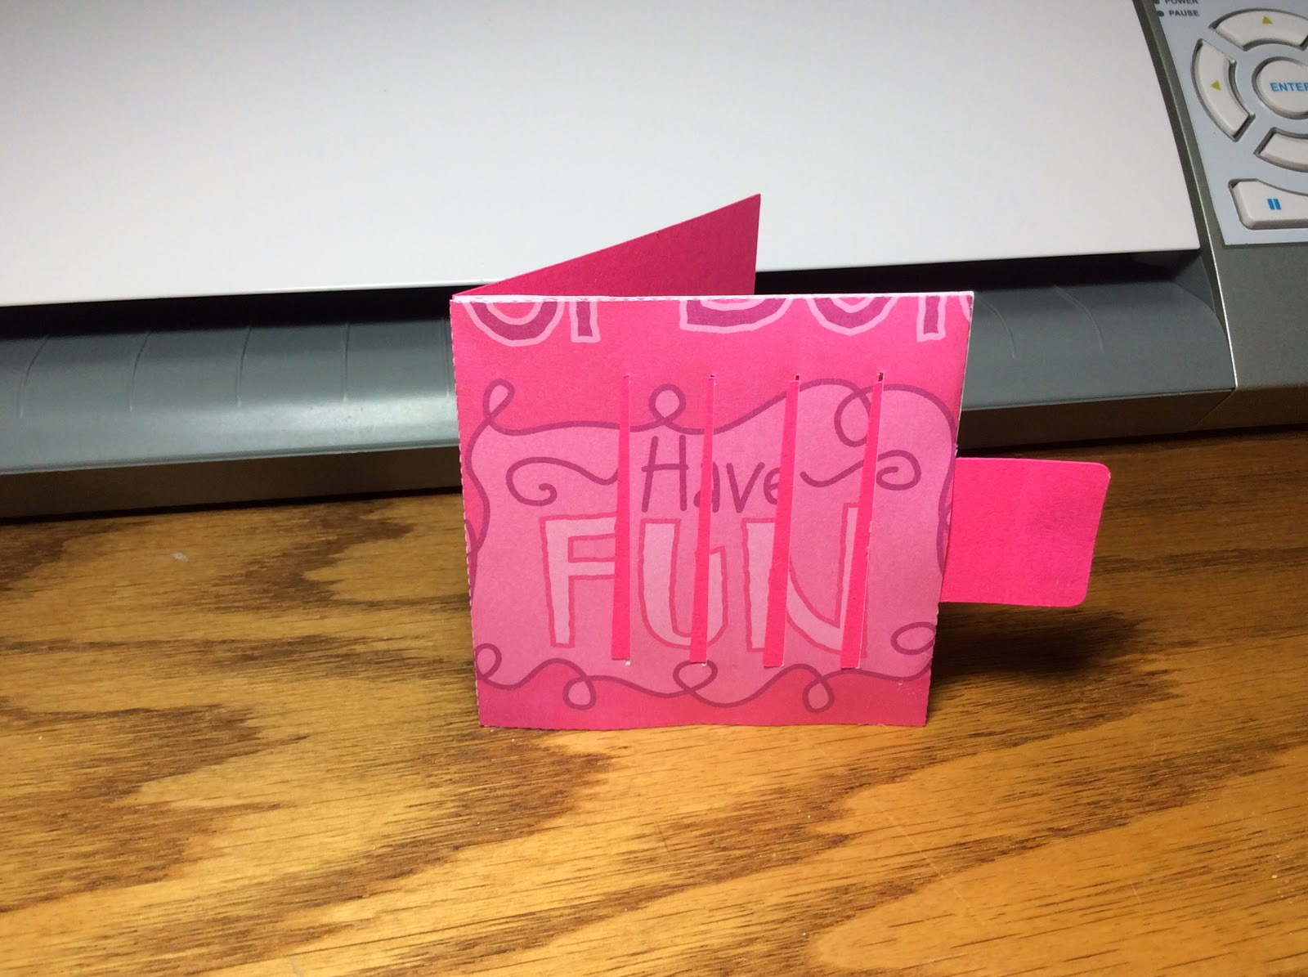

Card is in the open position. You can add a message here by gluing the four small rectangles onto each of the individual sections. As shown below.



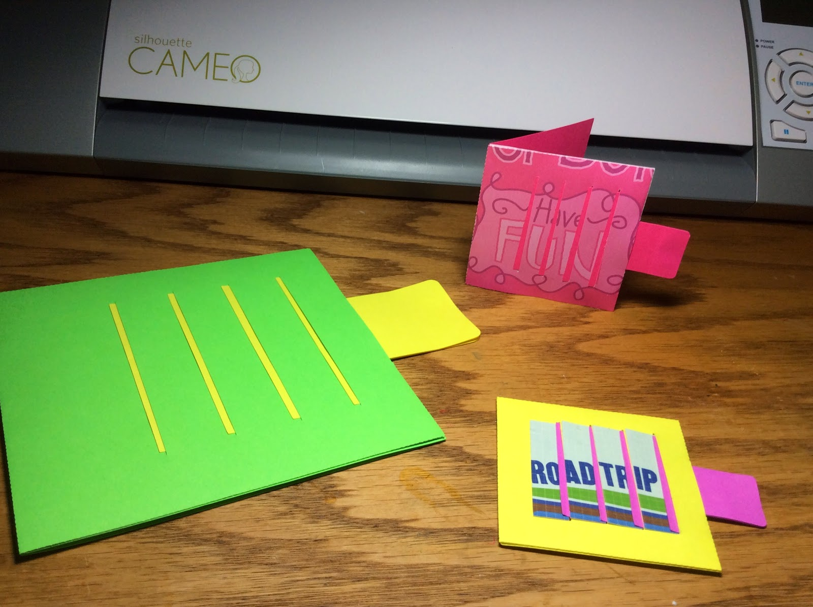

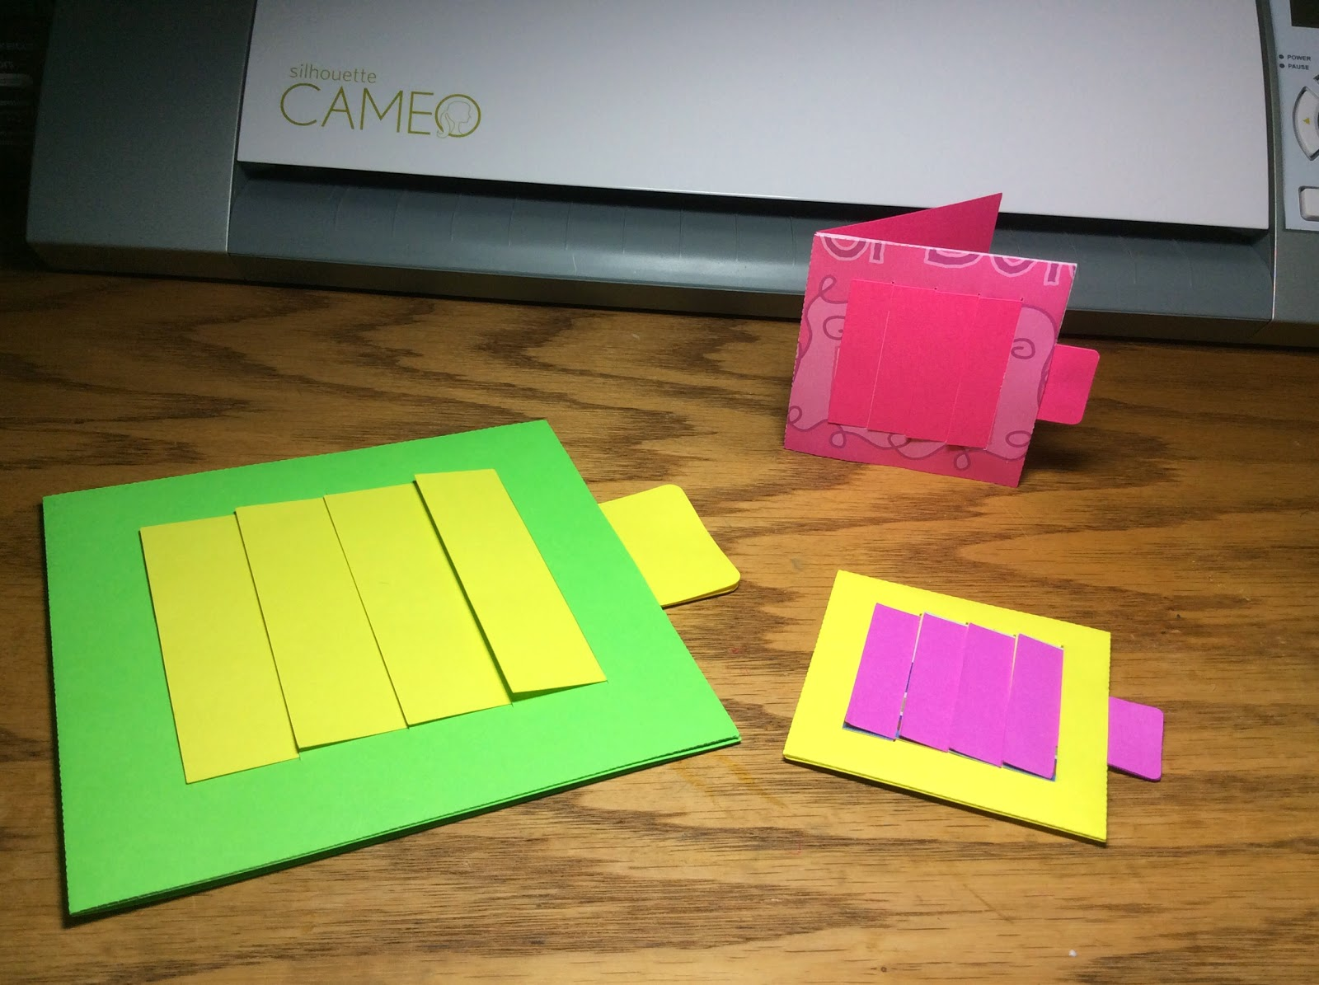

An assortment of sizes.

This can be done by resizing the image using your Silhouette software.